
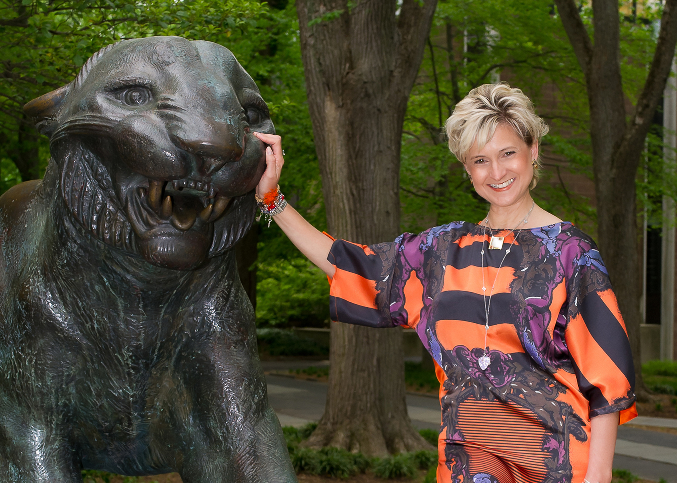

ANTONIO BERARDI

Antonio never disappoints. His striking, classical designs allow women to go from day to night with incredible ease. The sensuality of his color blocked, figure-hugging dresses with an added flare at the hemline, are just delectable.(as seen below)

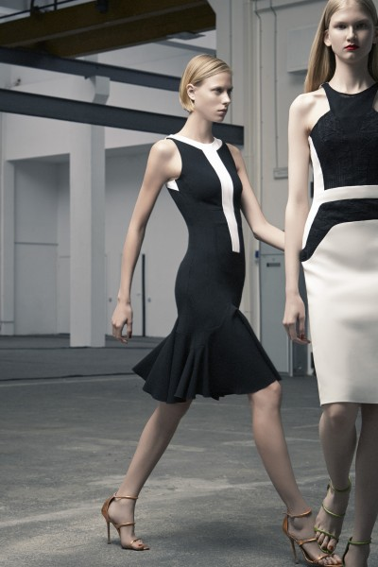

Antonio’s suits seen below, clearly demonstrate the cultural heritage of Antonio. These sophisticated Italian suits with a structured British style, are a wonderfully sexy addition to a women’s wardrobe.

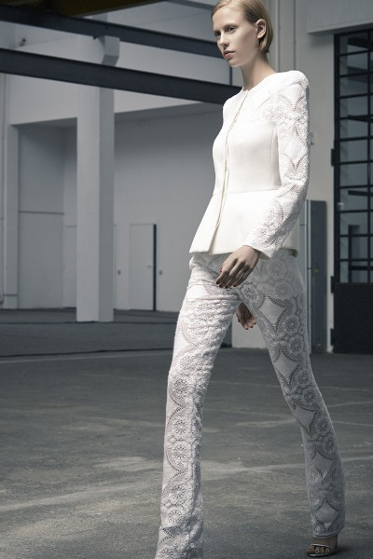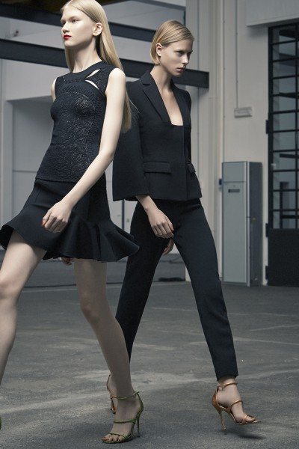

A peplum here, a geometric pattern there, adorns these sexy bodycon dresses, pants and suits. Structured seams lend structure to the fitted silhouettes.

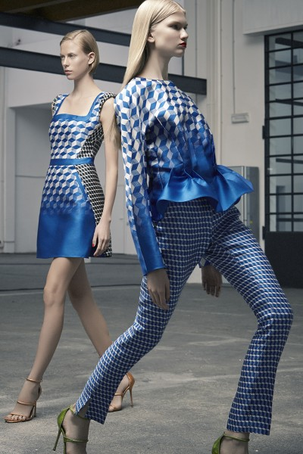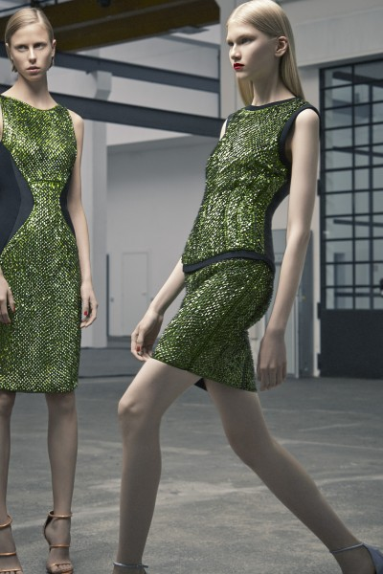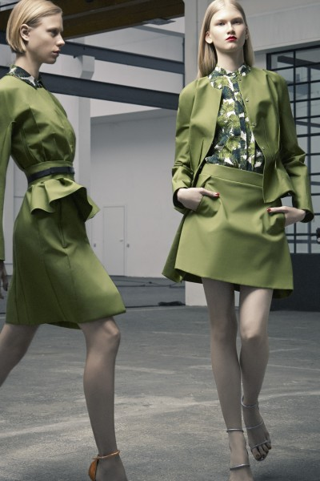

With this gown, I would like to see it without the sheer silk bottom, lengthen the red dress, narrow the dresses hem….you would have a spectacularly, sexy dress.

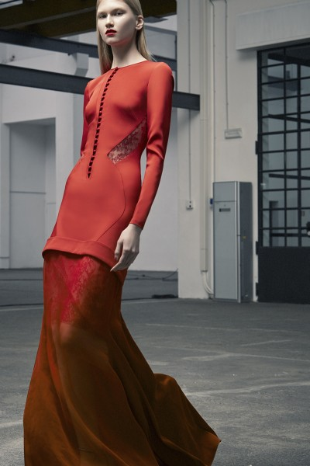

Review by DUFFY: Nov 2013

